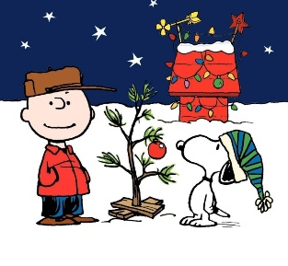



DECEMBER SPECIALS
AVAILABLE ALL DAY EVERY DAY
Chicken Fried Steak Sandwich: A cozy, winter sandwich featuring a crispy, chicken fried steak patty topped with our spicy sausage gravy and sandwiched between two thick-cut slices of Texas toast. Served with mashed potatoes and sausage gravy, or French fries. $14.95
Pickle Dry Rub OR Spicy Pickle Dry Rub Wings: The secret’s out: we are releasing a new menu, and you can be one of the first to try one of its new item additions! We created two new seasoning blends for our wings that scream, “PICKLES”! You have the option of choosing your wings (1lb) to be tossed in either our regular or spicy pickle dry rub. Served with celery, and a side of Ranch or Blue Cheese. $13.95
Chicken Bacon Alfredo Calzone: A baked pizza turnover stuffed with chicken, our delicious homemade alfredo sauce, chopped bacon and mozzarella cheese, then baked to a golden brown and topped with garlic butter and basil seasoning. Served with a side salad. $17.95
Turtle Cheesecake Slice: A classic combination for a reason, this cheesecake is made with graham cracker crust, a layer of fudge, creamy cheesecake, caramel syrup and chopped pecans. $9.95
DECEMBER LUNCH SPECIALS 11AM-2PM
1  Breaded Pork Sandwich $10.50 | 2  Meatball Sub $9.99 | 3  Italian Panini $10.25 | 4  Lunch Buffalo Chick Salad $9.99 | 5  Cuban Sandwich $9.99
8  Chicken Parmesan $10.99 | 9  Chicken Salad Croissant $9.99 | 10  Beef Tips on Noodles $10.95 | 11  Walleye Po-Boy $10.75 | 12  Turkey Avocado Wrap $9.99
15  Popcorn Shrimp Basket $9.99 | 16  Tater Tot Hotdish $9.99 | 17  Brat with Kettle Chips $9.99 | 18  Alfredo Chicken Sand $10.25 | 19  Shaved Prime Rib Sand $10.99
22  Chili Cheese Dog $9.99 | 23  Chicken Ceasar Wrap $9.99 | 24  Goulash with Garlic Toast $9.99 | 25  DINING ROOM CLOSED HAPPY HOLIDAYS! | 26  Italian Panini $10.25
29  Pork Chop Dinner $10.25 | 30  Tuna Melt $9.99 | 31  Turkey Commercial $10.25

