HAPPY HOUR SPECIALS
MONDAY-THURSDAY 3PM-6PM
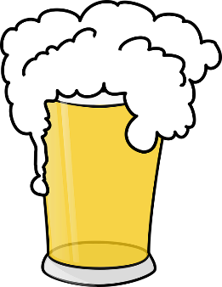
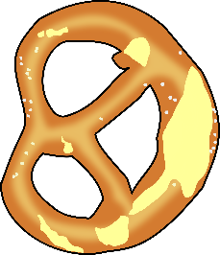
FRIDAY 2PM-5PM

{ BEVERAGES }

$4 WELL DRINKS

$4 MINNESOTA CRAFT PINTS

$4 PINTS MICH LIGHT, COORS LIGHT,
MILLER LITE OR BUDWEISER

$4 HOUSE WINES (CHARDONNAY, PINOT GRIGIO, SAUVIGNON BLANC, WHITE ZINFANDEL OR CABERNET)

{ FOOD }
$7 APPETIZERS
Fried Pickles,
Large Onion Rings, Cheese bread, Fried Mushrooms, Tater Tots

$8 APPETIZERS
Mozzarella Sticks, Cheese Curds,
Beef or Chicken Quesadilla

$9 APPETIZERS
Giant Pretzel, 4 Boneless Chicken Strips, 1LB of Wings, Walleye Fingers,
Half order of Nachos (Beef or Chicken)

